Light Following Robot

ACKNOWLEDGEMENT
Firstly, we thank Almighty Allah for granting us the strength, patience, and ability to complete this project successfully. We also send peace and blessings upon the Holy Prophet Muhammad (Peace Be Upon Him), whose teachings guide us in every aspect of life.
We are deeply grateful to our respected supervisor, Dr. Muhammad Munwar Iqbal and Shaheer Bhai for his continuous guidance, encouragement, and valuable suggestions throughout this project. Their support helped us understand both the theoretical and practical aspects of embedded systems.
We would also like to thank our parents for their prayers, moral support, and motivation. Finally, we are thankful to our friends and classmates who helped us during different phases of this project.

ABSTRACT
This project presents the design and implementation of a Light Following Robot using Arduino Uno. The robot is an autonomous system that detects and follows a light source using Light Dependent Resistors (LDRs). The change in light intensity is sensed by the LDRs and processed by the Arduino microcontroller which then controls the movement of DC motors through an L293D motor driver shield. The robot moves towards the direction where the light intensity is higher. This project demonstrates the basic concepts of robotics, sensor interfacing, and motor control, making it suitable for beginners in embedded systems and robotics.

TABLE OF CONTENTS
Acknowledgement………………………………………………… | 2
Abstract…………………………………………………………… | 3
Introduction……………………………………………………….. | 5
Project Aim and Scope……………………………………………. | 5
Objectives of the Project………………………………………….. | 5
Description of the Project…………………………………………. | 5
Hardware and Software Requirements……………………………. | 6
Description of Hardware Components……………………………. | 6
Working Principle………………………………………………… | 8
Design and Implementation………………………………………. | 11
Advantages and Disadvantages…………………………………… | 12
Applications……………………………………………………….. | 12
Future Enhancements……………………………………………... | 12
Conclusion………………………………………………………… | 12
References………………………………………………………… | 13

INTRODUCTION
Robotics is an important field of engineering that combines electronics, programming, and mechanical design. Autonomous robots are widely used in modern applications such as industrial automation, surveillance, and exploration. A light following robot is a simple form of autonomous robot that moves in the direction of a light source.
In this project, a light following robot is designed using Arduino Uno and LDR sensors. The robot uses two LDRs placed on the left and right sides to detect the intensity of light. Based on the sensor readings, the Arduino controls the motors using an L293D motor driver shield. This project helps students understand basic concepts of sensors, microcontrollers, and motor control.

PROJECT AIM AND SCOPE
The aim of this project is to design and develop a simple autonomous light following robot that can detect and move towards a light source.
Scope of the Project:
- To demonstrate basic robotics concepts
- To understand sensor interfacing with Arduino
- To learn motor control using a motor driver
- Suitable for educational and learning purposes

OBJECTIVES OF THE PROJECT
- To detect light intensity using Light Dependent Resistors (LDRs)
- To process sensor data using Arduino Uno
- To control DC motors using L293D motor driver shield
- To design a robot capable of forward and turning movements
- To implement autonomous navigation towards a light source

DESCRIPTION OF THE PROJECT
The light following robot consists of an Arduino Uno, two LDR sensors, an L293D motor driver shield, DC motors, and a robot chassis. The LDR sensors detect light from different directions. The Arduino compares the readings from both sensors and decides the movement of the robot. If the left sensor detects more light, the robot turns left. If the right sensor detects more light, the robot turns right. If both sensors detect equal light, the robot moves forward.

HARDWARE AND SOFTWARE REQUIREMENTS
Hardware Requirements:
- Arduino Uno R3
- L293D Motor Driver Shield
- Light Dependent Resistors (LDRs)
- 10k Ohm Resistors
- DC Gear Motors
- Robot Chassis (2WD)
- AA Batteries / Power Supply
- Connecting Wires
Software Requirements:
- Arduino Integrated Development Environment (IDE)

DESCRIPTION OF HARDWARE COMPONENTS
Arduino Uno
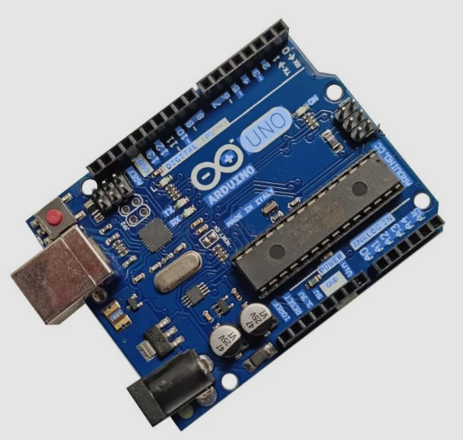
Figure 1: Arduino UNO R3

Arduino Uno is the main control unit of the robot. It reads input from the LDR sensors, processes the data, and sends control signals to the motor driver.
L293D Motor Driver Shield:
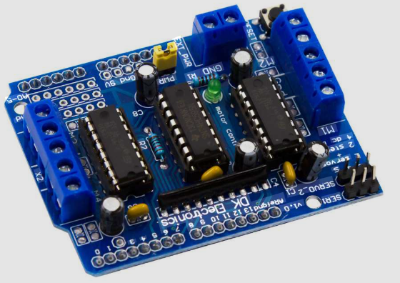
Figure 2:L293D Motor Driver Shield

The motor driver shield allows the Arduino to control the DC motors. It provides sufficient current and voltage required to run the motors and enables forward and reverse motion.
Light Dependent Resistor (LDR):
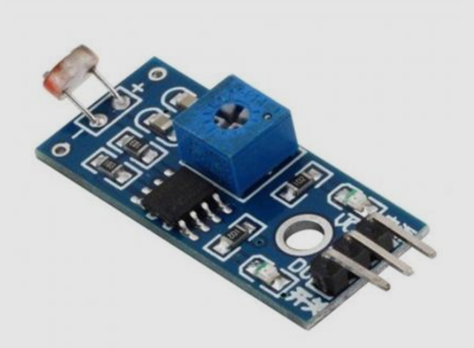
Figure 3:light dependent register

An LDR is a sensor whose resistance changes with light intensity. It provides analog input to the Arduino, allowing the robot to detect the direction of light.

WORKING PRINCIPLE
The working principle of the light following robot is based on light intensity comparison. Two LDR sensors continuously measure the light intensity. The Arduino compares the values:
- If left LDR value is higher, the robot turns left
- If right LDR value is higher, the robot turns right
- If both values are equal, the robot moves forward
This process continues continuously, allowing the robot to follow the light source automatically.
Code:
#include <AFMotor.h>

//defining pins and variables
#define lefts A0
#define rights A1

//defining motors
AF_DCMotor motor1(1, MOTOR12_1KHZ);
AF_DCMotor motor2(2, MOTOR12_1KHZ);
AF_DCMotor motor3(3, MOTOR34_1KHZ);
AF_DCMotor motor4(4, MOTOR34_1KHZ);

void setup() {
//Setting the motor speed
motor1.setSpeed(180);
motor2.setSpeed(180);
motor3.setSpeed(180);
motor4.setSpeed(180);
//Declaring PIN input types
pinMode(lefts,INPUT);
pinMode(rights,INPUT);
//Begin serial communication
Serial.begin(9600);

}

void loop(){
//Printing values of the sensors to the serial monitor
Serial.println(analogRead(lefts));
Serial.println(analogRead(rights));
//light detected by both
if(analogRead(lefts)<=350 && analogRead(rights)<=350){
//Forward
motor1.run(FORWARD);
motor2.run(FORWARD);
motor3.run(FORWARD);
motor4.run(FORWARD);
}
//light detected by left sensor
else if(analogRead(lefts)<=350 && !analogRead(rights)<=350){
//turn left
motor1.run(FORWARD);
motor2.run(FORWARD);
motor3.run(BACKWARD);
motor4.run(BACKWARD);

}
//light detected by right sensor
else if(!analogRead(lefts)<=350 && analogRead(rights)<=350){
//turn right
motor1.run(BACKWARD);
motor2.run(BACKWARD);
motor3.run(FORWARD);
motor4.run(FORWARD);

}
//light detected by none
else if(!analogRead(lefts)<=350 && !analogRead(rights)<=350){
//stop
motor1.run(RELEASE);
motor2.run(RELEASE);
motor3.run(RELEASE);
motor4.run(RELEASE);

}

}

DESIGN AND IMPLEMENTATION
The robot was designed by assembling the hardware components on a robot chassis. The Arduino was programmed using Arduino IDE. The LDRs were connected to analog pins, and motors were connected through the L293D motor driver shield. After uploading the code, the robot was tested using a flashlight as a light source and performed successfully.
Circuit Diagram:
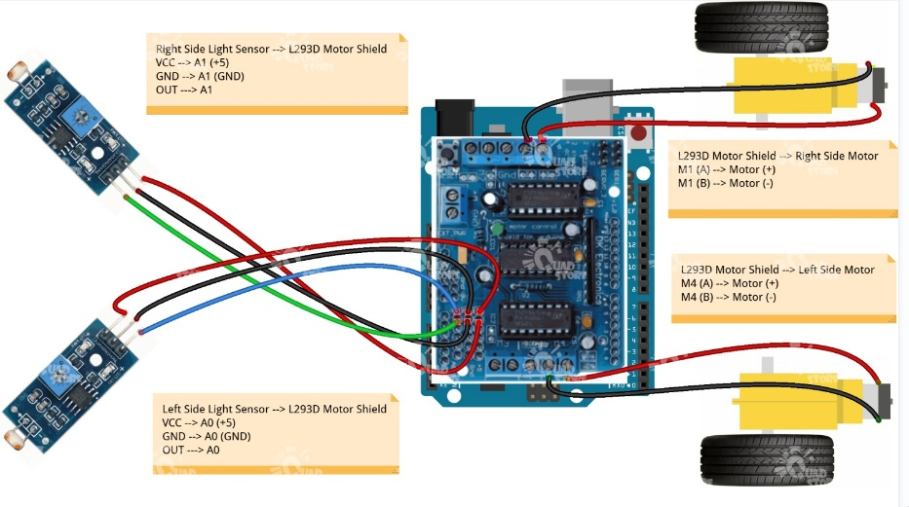
Figure 4:circuit Diagram light following robot

ADVANTAGES AND DISADVANTAGES
Advantages:
- Simple and low-cost design
- Easy to understand and implement
- Useful for learning robotics basics
- Autonomous operation
Disadvantages:
- Works best with a single light source
- Cannot detect obstacles
- Performance affected by ambient light

APPLICATIONS
- Educational robotics projects
- Learning embedded systems
- Demonstration of sensor based automation
- Basic research and experimentation
- Search and Rescue Operations
- Solar Panel Alignment

FUTURE ENHANCEMENTS
- Adding obstacle detection sensors
- Using more accurate light sensors
- Implementing speed control using PWM
- Integrating wireless control features

CONCLUSION
The light following robot project was successfully designed and implemented using Arduino Uno. The robot demonstrated autonomous behavior by accurately detecting and following a light source. This project enhanced our understanding of microcontrollers, sensors, and motor control. It is a good starting point for beginners interested in robotics and embedded systems.

REFERENCES
- www.arduino.cc
- www.electronicsforu.com
- www.engineeringprojects.com
- www.quora.com

